**That explains how to use the website**

**Step 1 Login the website**

* **The website will allow users to enter the username and password**
* **If an error the pop up/message will display saying there is an error or invalid credentials**

**Step 2**

* **The user can add multiple modules for semester**

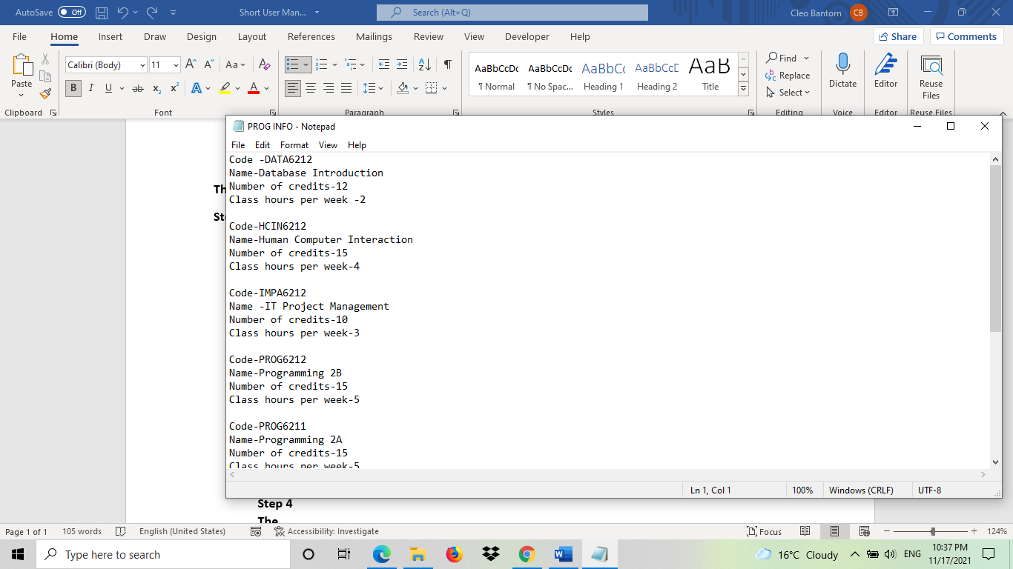

**Step 3**

* **Then add the list of modules which will work together with the**

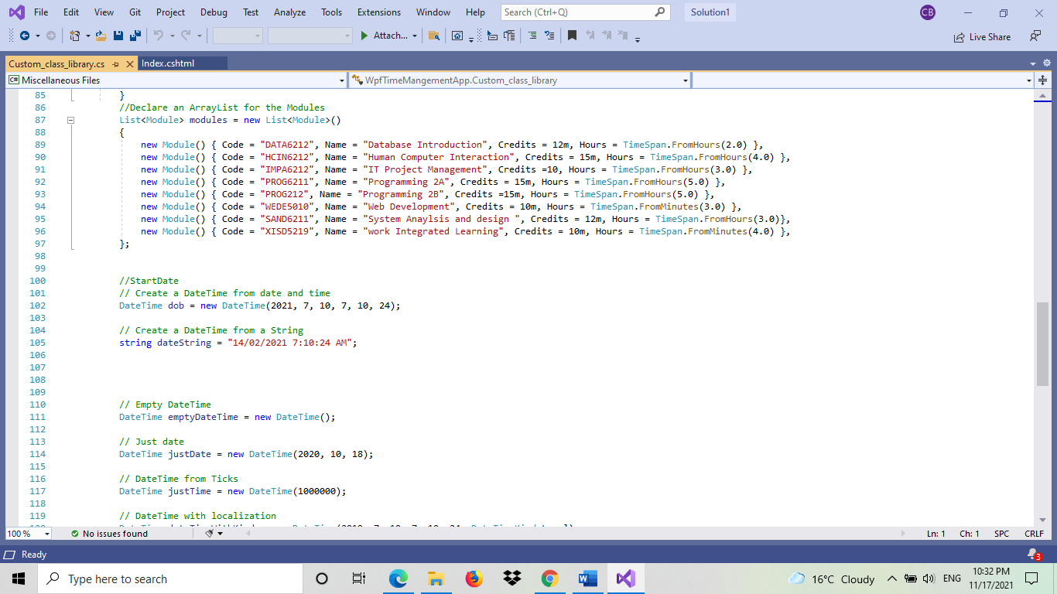

**Step 4**

**The**

**hours spent on a module**

**can be captured, and the**

**number of self-studies**

**hours remaining is**

**correctly calculated and displayed**

**step 5**

**The**

**data is persisted in the**

**database and loaded**

**again, when the user logs the next time**